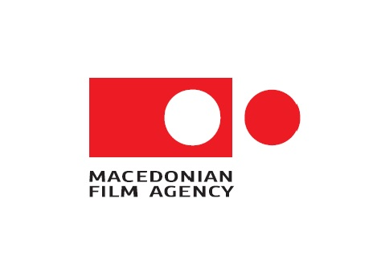


APPLICATION FORM
Italian-Macedonian Co-production Development Fund
(for full –length feature films)

Application Deadline: 12th September 2016

 |  |  |  |  |  |  |  | Date:
Italian Producer |  |  |  |  | Macedonian Producer
Mr | Ms | First and Surname  (use box below to fill in) |  |  | Mr | Ms | First and Surname  (use box below to fill in)
  (x)
  (x)
Company |  |  |  |  | Company
No. enrolment in the list of DGC
Address |  |  |  |  | Address
ZIP Code |  |  |  | City | ZIP Code |  |  |  | City
E-mail |  |  |  |  | E-mail
Phone |  |  |  |  | Phone
Mobile |  |  |  |  | Mobile
Website |  |  |  |  | Website
Project information
Title of the project |  |  |  |  | Screenwriter (Nationality)
Genre (fiction, documentary or animation) |  |  |  |  | Majority Producer
Director  (Nationality) |  |  |  |  | Minority Producer
 |  |  |  |  | Indicate share |  | Majority |  |  |  | Minority
 |  |  |  |  | %
 |  |  |  |  | EUR
Script |  |  | Yes No |  | Treatment |  | Yes No
  (x)
  (x)
Development Budget in € |  |  |  |  | Production Budget in €
Language |  |  |  |  | Shooting Location/s

Please send the following documents:

- This application form, completed (as a word document)

For Administrative dossier:
- 1-2 page CV for producer /including a list of films produced by the company (both Macedonian and Italian)
- The deal memo or a co-production agreement for the project
- Contracts providing the acquisition of necessary rights (e.g. option contract, scriptwriter’s contract etc.)
- Report on project development stages
- Development budget in €
- Development financing plan in €

For participants who apply with script also is needed:
- Estimated production budget in €
- Financing plan in €

For Artistic dossier:
- Script (if they apply with script)
- Completed treatment (approx. 12 pages including two dialogue scenes)
- 1 page synopsis
- 1-2 page CV for screenwriter/director (in case the director has already been selected)
- Note of intent from the writer/director (1 page max.- in case the director has already been selected)
- Note of intent from the producer (regarding the project)
- Graphic development (only for animation films)
- Project description and a concept for the implementation (only for documentaries)

All written documents must be in English or in the original language version and a corresponding translation (Macedonian or Italian)

Please name the PDF file as follows:
TITLE OF PROJECT_COUNTRY

The applicant declares:  - this is a new project which has not already received public funding from other institutions | □ Yes | □ No
- if no, please indicate which institutions or sources have already funded the project ____________________________________________________________________

The applicant agrees:
- That the materials will not be returned to the applicant;
- The measures to be funded must have not been initiated prior to the application submission.

The applicant is aware of the fact that:
- the project does not contain pornographic content, nor does it promote violence
- the content of the project does not contradict the Constitution or laws pertaining to public funding
if the project violates criminal law, the funding will be immediately withdrawn and must be repaid

The applicant assures that the information provided in this application is correct and truthful. If this is not the case, the funding will be immediately withdrawn and must be repaid. Violations of this declaration will be prosecuted according to criminal law and public subsidy legislation.

_________________________________

Place, Date

_______________________________________________

Signature Italian partner
_______________________________________________

Signature Macedonian partner

Declaration of protection of data privacy:
- the applicant agrees that all information in this application may be used by the funding institutions for promotional purposes

_______________________________

Place, Date

_______________________________________________

Signature main producer

The Financial support assigned is subject to Regulation no. 1998/2006 of the European Commission of December 15th 2006, in compliance with articles 87 and 88 of the European Treaty concerning de minimis constraints. By reason of this regulation, the same beneficiary cannot receive more than EUR 200.000 Euros during 3 consecutive fiscal years.
I declare that a comprehensive amount of de minimis aid received to date during the current fiscal year and the previous two fiscal years will not exceed the sum of 200.000 Euros.

______________________________________________  Place, Date  ______________________________________________  Place, Date | _______________________________________________  Signature Italian partner  ______________________________________________  Signature Macedonian partner

Please note!

Your application will only be considered if all requirements are met within the extended deadline
12th September 2016

All documents should be submitted in English or in the original language version and a corresponding translation (Macedonian or Italian).

Please complete this form and send it together with other requested documents to:

The Directorate General Cinema of the Ministry of Cultural Heritage Activities and Tourism (DGC-MiBACT) email address: fsim@beniculturali.it

Macedonian Film Agency (MFA) email address: contact@filmagency.gov.mk

As for Italian majority projects, the projects should be submitted in Italian to MiBACT and in English or Macedonian to MFA. Exceptions are accepted only for contracts that can be submitted in English with an Italian short-form translation. As for Macedonian majority projects, the projects should be submitted in English or Macedonian to MFA and could be submitted in English to MiBACT.

